Week 1 - Introduction to Web Development

Zoom Overview

* Start Audio - bottom left
  + 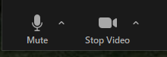
* Start Video - bottom left
* Practice muting and unmuting - bottom left
* Full screen top right
* Please set your name to what you want to be called
  + 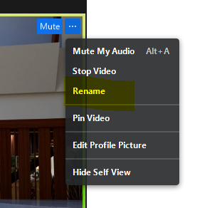
* Gallery view or speaker view, Be sure to maximize if you have a small screen
  + 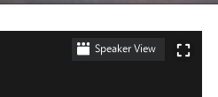
* Send the class a chat “Chat from Chuck Siebsen”, everyone respond with name.
  + 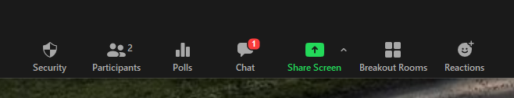
* Each student send me a chat, can be public or private
  + 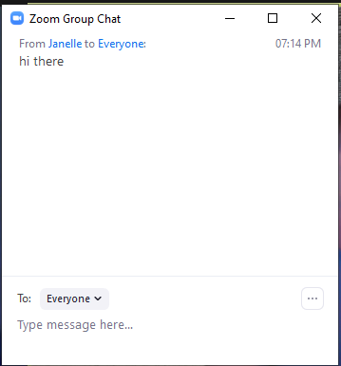
* Send a private chat to Jacob Hester else, say something nice.
* Share Screen (most of the time in this mode)
  + Option of what to do with video of instructor > Audio only,  small, can switch to larger, or see group
  + Can swap back and forth with instructor or shared screen
  + 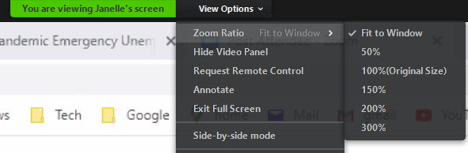
* Create and demo white board
  + 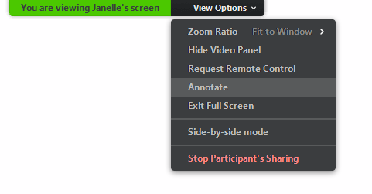
  + 
* Poll Operating System What Operating System are you using? MACos, Windows, Unix, Linux, Other, What is an Operating System?
* Share a screen, have everyone do View Options > Annotate > drop arrow on screen
* Can everyone see and hear OK?
* Videos are recorded and available for a week. Contact Jacob or me for link.

Class guidelines

1. Take attendance
2. In general stay on mute to cut down on background noise
3. I welcome questions and dialogue.  Feel free to ask me anything
4. Will take regular breaks throughout 3 hours of meetings.
5. Classes build on one another so try not to miss any.
6. Learn the material and have fun doing it.

Class Tips

Second monitor, more real estate, can take notes or program on one screen, watch class in another.

Possibly find one used if finances are an issue, but you can take the course just on a laptop

Who am I?

Chuck Siebsen

[csiebsen@techtalentsouth.com](mailto:csiebsen@techtalentsouth.com)

Reachable on Slack?

Minnesota native, now living in North Carolina

Worked as a developer about 35 years, 20 years as web developer using Java

Have worked for about 12 companies

Wells Fargo

3M

Cargill

Carlson Companies

Several small companies

Multiple industries

Banking

Software Company

Medical Device

Marketing

Manufacturing

Government

Love to code, “Find a job you love and you’ll never work a day in your life.”

Interesting thing about me, “Bucket list” trip to Italy

Who are you?

Share name, physical location, why you are taking this course.

Windows machines vs. Mac machines

SNIPPING TOOL Review

Ever wish you could take picture during presentation

Picture paints a thousand words,

sometimes you need to quick save what’s on the screen

WINDOWS - Snipping Tool – Type Snip in windows Search bar

MAC (GRAB)- Open it from the Utilities folder under Applications.

* Type /Applications/Utilities/Grab.app in Finder.
* Open Launchpad → Other → Grab.
* Open Spotlight and type in Grab.

Review Syllabus

Review accessing slides, homework after class